The simulation about signal processing in wavenumber and scanning distance domains of white-light interferometers

**~~I. The first case: φ~~~~d~~~~(σ) = 0 and I(σ) is symmetric.~~**

**0. Equations in theory**

Fig.1 shows a white-light scanning interferometer (WLSI) with a white-light source whose spectral intensity is *I*(*σ*), where *σ* is wavenumber. The position of an object surface is *zo*, and the position *z* of a reference surface is scanned by a piezoelectric transducer (PZT). An interference signal is detected with a camera when the PZT is moving. The interference signal has the two components and one of them is constant during the scanning of *z*. Omitting this constant component, the interference signal expressed as a function of the scanning position z is given by

.

Assume  is defined as



where phase *ϕd*(*σ*) is a dispersion phase caused by two sides of unequal length in a cubic beam splitter. Fourier transform of  or the spectral distribution in the region of positive wavenumbers is expressed as



IFT (Inverse Fourier transform) ofis defined as



So, there are two Fourier transform pairs.





where *L*=2(*z*-*zO*) and *L* is the optical path difference.

In addition, assume that  and  form a Fourier transform pair.



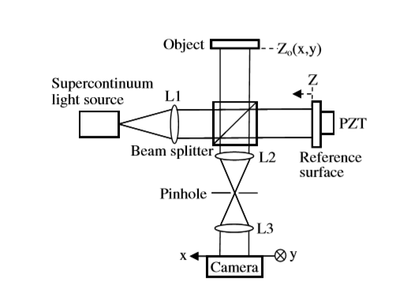

Fig. 1 Schematic of a white-light scanning interferometer.

**I. The first case: φd(σ) = 0 and I(σ) is symmetric.**

When the distribution of ~~~~ *I′*(*σ*) is symmetric is evenly symmetric about the origin, *A(2z)=A(-2z)* and . ~~~~ *I′*(*σ*) is shown in Fig.2. When  is translated by  from the origin to the right, it is equal to that the distribution of *I*(*σ*) is symmetric with a central wavenumber , and .

 *I′*(*σ*-*σC*)= *I*(*σ*)

When ,



[It is important that you can explain Eq.(9) with sentences by using properties of Fourier transform.]

In the case of , the distributions of *SC*(*z*) ~~is~~ are shown in Figs.3(a c) and ~~Fig.3~~(b d).



Fig. 2 The distribution of *I*(*σ’*) and spectral intensity *I*(*σ*)

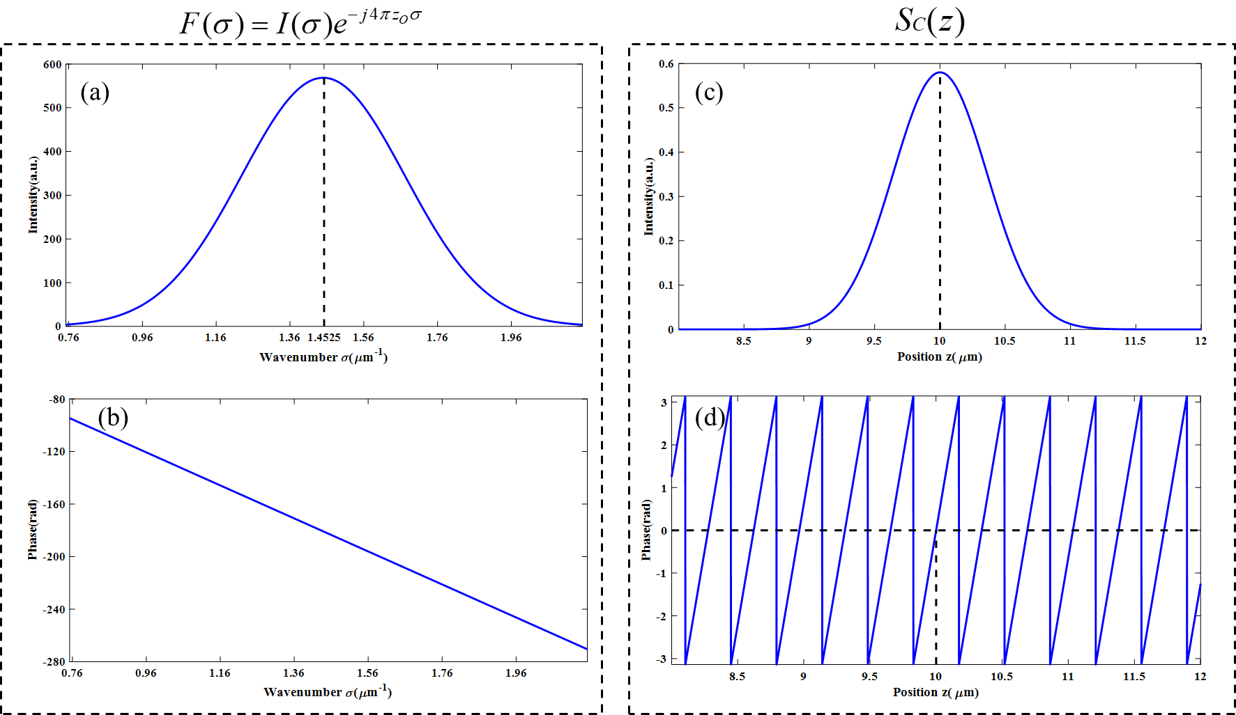

Fig. 3 IFT (Inverse Fourier transform) of *F(σ)*. (a) The intensity of *F(σ)*. (b) The phase of *F(σ)*.

(c) The intensity of *SC(z)*. (d)The phase of *SC(z).*

According to the Eq.(9), the amplitude distribution of *SC*(*z*) is *A(2(z-zO))* and the phase distribution of *SC*(*z*) is .

[It is important that you can explain Eq.(9) with sentences by using properties of Fourier transform.]

So, the peak position in the amplitude distribution of *SC*(*z*) is *za=zo*, and the zero phase position nearest z=*za* is *zp=zo*. The period of the unwrapped phase distribution is



Fig.3 shows the simulation about the IFT(Inverse Fourier transform) of *F(σ)*. The relevant parameters of *F(σ)* and *SC(z)* are shown in Table 1.

Table 1. The relevant parameters of *F(σ)* shown in Figs.3 (a) and (b) and *SC(z).*

|  |  |  |  |  |  |
| --- | --- | --- | --- | --- | --- |
| σC | zO | λC | ~~z~~~~a~~ | ~~z~~~~p~~ | ~~T P~~ |
| 1.4525μm-1 | 10μm | 0.6884μm | ~~10.0000μm~~ | ~~10.0000μm~~ | ~~0.3448μm~~ |

σC: Central wavenumber of *I(σ)*.

zO: The position of an object surface.

λC: Central wavelength of *I(λ)* and *λC = 1/σC.*

Simulation results shown in Figs.3 (c) and (d).

|  |  |  |
| --- | --- | --- |
| za | zp | ~~T~~ P |
| 10.0000μm | 10.0000μm | 0.3448μm |

za : The peak position in the amplitude distribution of *SC*(*z*).

zp : The zero-phase position in the phase distribution of *SC*(*z*).

~~T~~ P : The period of the unwrapped phase distribution of *SC*(*z*).

**II. The second case: φd(σ) = 0 and I(σ) is asymmetric.**

To simulate the spectral distribution of an actual light source, the distribution of *I*(*σ*) is asymmetric with a weighted average wavenumber *σA*. The distribution of *I(σ)* is shown in Fig.4(a). The weighted average wavenumber *σA* is defined as



In order to obtain a more realistic and asymmetric spectral distribution *I(σ)*, here *I(σ)* is obtained by performing multi-order Gaussian fitting of the actual spectrum. *I(σ)* can be expressed as



IFT of *Gi(σ)* is defined as ~~~~. 



So,





From Euler’s formula we can get the intensity and phase distribution of *SC(z)*,





Where *L=2(z-zO)* and ??[Is this correct?].

Owing to *Si(L) = -Si(L)*, the intensity distribution *A(L)* is evenly symmetric about L= 0 and phase distribution *α(L)* is oddly symmetric about L= 0. According to the Eq.(15), the peak position in the amplitude distribution of *SC*(*z*) is *za=zo*, and the zero phase position nearest z=*za* is *zp=zo*. Similarly, according to the Eq.(10), the period P of the unwrapped phase distribution is almost equal to *1/2σA*=*λA*/2.[Please check this value in Fig.4(d).]

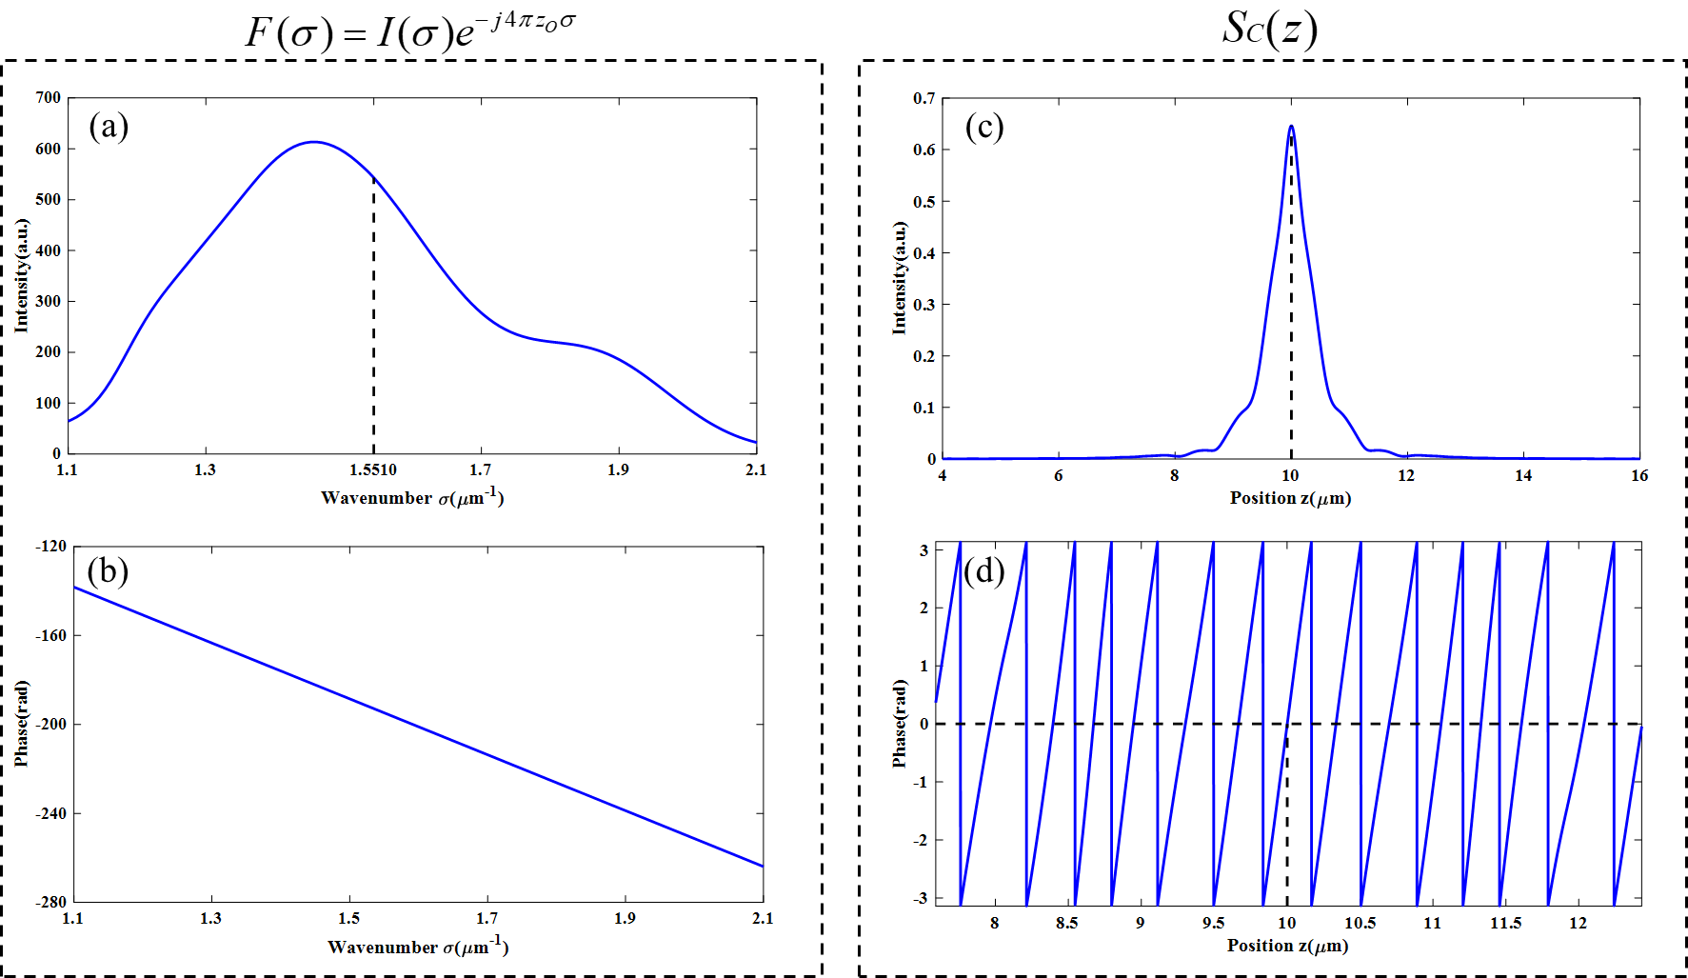

(e)

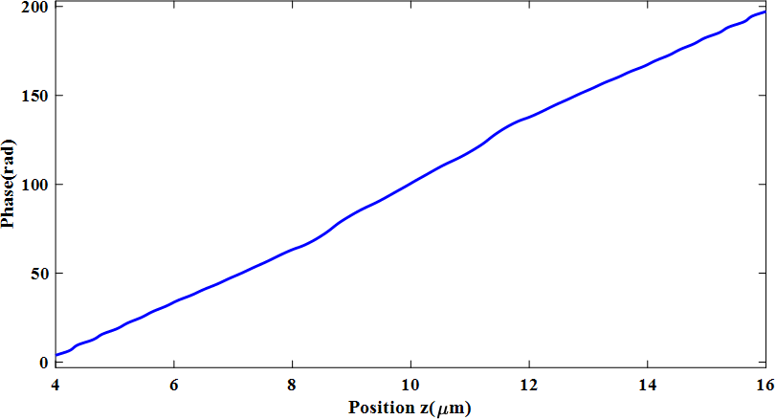

0

unwrap

Fig. 4 IFT (Inverse Fourier transform) of *F(σ)*. (a) The intensity of *F(σ)*. (b) The phase of *F(σ)*.

(c) The intensity of *SC(z)*. (d)The phase of *SC(z).* (e) The unwrap phase of *SC(z).*

Fig.4 shows the simulation about the IFT(Inverse Fourier transform) of *F(σ)*. Fig.4(a) shows the intensity of *F(σ)*. The interference signal in wavenumber domain is generated in the region from 1.1 μm-1 to 2.1 μm-1 where the weighted average wavenumber *σA* is 1.5510 μm-1 , and the sampling interval ∆σ and the sampling number are 0.00092 μm-1 and 65535, respectively. The phase of *F(σ)* as shown in Fig.4(b) in which the value zO is 10 μm. The intensity and phase of *SC(z)* which is IFT(Inverse Fourier transform) of *F(σ)* as shown in Fig.4(c) and Fig.4(d), respectively. ~~A part~~ Amplitude of the interference signal ~~in space domain~~ is shown ~~selected by a rectangular window whose width was~~ in the region from 4 μm to 16 μm where the value za is 10.0009 μm, as shown in Fig.4(c). The other data outside ~~the rectangular window~~ this region almost are zero values. In the Fig.4(d), phase of *SC(z)* is wrapped between -π to π [it is important which point of zero rad in the wrapped phase is zero rad in the unwrapped phase. From the theory, zero rad in the unwrapped phase is near to z=za.]and the value of zp is 10.0009 μm which is equal to za. After unwrapping the phase as shown in Fig.4(e), it is found that the phase is nonlinear. [Please show the nonlinear component of Fig.4(e) by calculating {Fig.4(e) - least square line of Fig.4(e)}. ]

[It is important to describe the reason why Fig.4(e) contains the nonlinear component with sentences, not with equations. Please describe this reason.] The relevant parameters of *F(σ)* and *SC(z)* are shown in Table 2.

Table 2. The relevant parameters of *F(σ)* and *SC(z).*

|  |  |  |  |  |  |
| --- | --- | --- | --- | --- | --- |
| σA | zO | λA | ~~z~~~~a~~ | ~~z~~~~p~~ | ~~T P~~ |
| 1.5510μm-1 | 10μm | 0.6447μm | ~~10.0009μm~~ | ~~10.0009μm~~ | ~~0.3288μm~~ |

Simulation results

|  |  |  |
| --- | --- | --- |
| za | zp | ~~T~~ P |
| 10.0009μm | 10.0009μm | 0.3288μm |

[P=*λA*/2=0.3223μm, but its simulation value is 0.3288μm. What is the reason of the difference of 0.3288-0.3223=0.065μm?]

**III. The Third case: φd(σ) ≠ 0 and I(σ) is asymmetric.**

In this case, the distribution of *I*(*σ*) is asymmetric and there is a dispersion phase *ϕd*(*σ*). The *ϕd*(*σ*) is produced by an cand thickness T, *ϕd*(*σ*) is given by



Assume that T is 1μm. Then



So,



Different φd(σ) is considered ~~can be obtained~~ by assigning different values to the parameters.

1. **~~When~~ b0~~is~~ =35, b1 ~~is~~=-5**μm **and φd(σ) = -4π(35-5σ)σ;**

**(1.a) Effect of φd(σ)**

According to the expression of φd(σ), then

?? exp[-4πj(45-5σ)σ]

The distribution of intensity and phase of *F(σ)* as shown in Fig.5(a) and Fig.5(b), respectively. The IFT(Inverse Fourier transform) of *F(σ)* as shown in Fig.5(c) and Fig.5(d). After unwrapping the phase of *SC(z)*, as shown in Fig.4(e), it is found that the phase is nonlinear. In this case, za is equal to zO+2b0 = 90 μm??=10+70, but the length in the z domain after the inverse Fourier transform is 60.2410 μm??. Hence, za is equal to 29.759 μm??. [I do not understand the above values.]

The relevant parameters of *F(σ)* and *SC(z)* in the Fig.5 are shown in Table 3.

Table 3. The relevant parameters of *F(σ)* and *SC(z).*

|  |  |  |  |  |  |
| --- | --- | --- | --- | --- | --- |
| σA | zO | λA | ~~z~~~~a~~ | ~~z~~~~p~~ | ~~T P~~ |
| 1.5510μm-1 | 10μm | 0.6447μm | ~~30.5937μm~~ | ~~30.5308μm~~ | ~~0.3395μm~~ |
| b0 | b1 | b2 | b3 | ~~z~~~~p~~~~-z~~~~O~~ |  |
| 35 | -5 | 0 | 0 | ~~20.5308μm~~ |  |

Simulation results ??

|  |  |  |  |
| --- | --- | --- | --- |
| za | zp | zp-zO | ~~T~~ P |
| 30.5937μm | 30.5308μm | 20.5308μm | 0.3395μm |

[I do not understand the reason why Table 3 is obtained by the effect ofφd(σ).]

[Please explain the effect of φd(σ) comparing Table 3 and Table 2.]

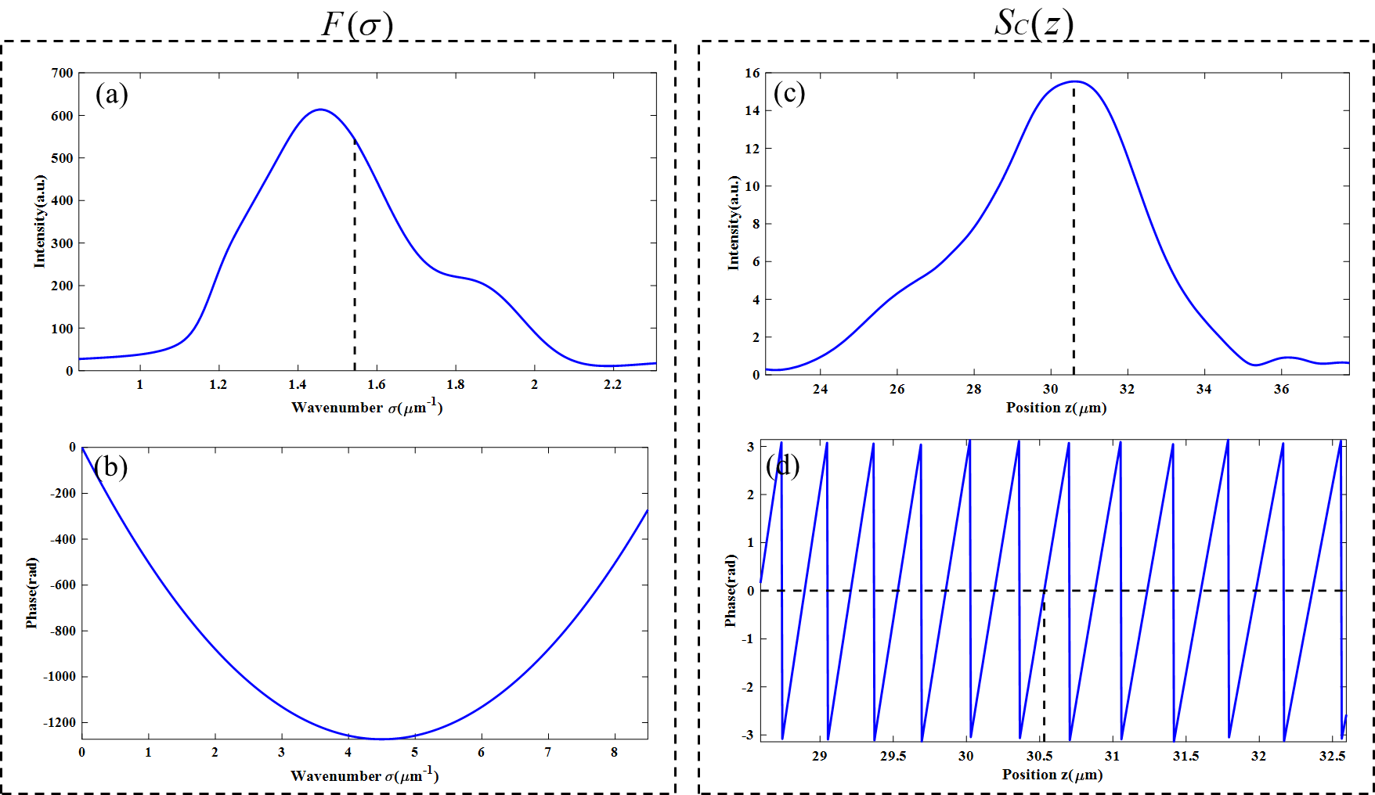

(e)



0

unwrap

Fig. 5 IFT (Inverse Fourier transform) of *F(σ)*. (a) The intensity of *F(σ)*. (b) The phase of *F(σ)*.

(c) The intensity of *SC(z)*. (d)The phase of *SC(z).* (e) The unwrap phase of *SC(z).*

**(1.b) Elimination of effect of φd(σ) by using a least square line for phase distribution φ (σ) of F(σ).**

The phase distribution φd(σ) will affect the measurement results, but the phase distribution φd(σ) can be eliminated by the least squares method [What is this?], as shown in Fig.6. The linear phase function fitted by the least squares method is

~~~~ 

where ~~the least square line of~~ *a1* = ~~4πz~~~~O~~ ~~- 31.99~~ #### and *a0* = -768.

[What are a1 and a0?]

[Is the least square line of φd(σ) = -4π(35-5σ)σ equal to a0+a1σ?]

[What is the least square line of φd(σ) = -4π(35-5σ)σ?]

[What is the relation between (b0=35, b=-5) and (*a*1= 4πzO - 31.99 and *a*0 = -768)? Or why are (*a*1= 4πzO - 31.99 and *a*0 = -768) obtained? ]

~~According to Eq.(3) of , then~~ By using the least linear line of

??

FL(σ)=I(σ)exp{-j4π[zo-(a1/4π)]σ+ja0}

So,





The ~~relevant parameters can be~~ simulation results obtained from Fig.6 are shown in Table 4.

Table 4. The ~~relevant parameters~~ simulation results of *F(σ)* and *SC(z).*

|  |  |  |  |  |  |
| --- | --- | --- | --- | --- | --- |
| ~~σ~~~~A~~ | ~~z~~~~O~~ | ~~λ~~~~A~~ | za | zp | ~~T~~ P |
| ~~1.5510μm~~~~-1~~ | ~~10μm~~ | ~~0.6447μm~~ | 2.5921μm | 2.6798μm | 0.3233μm |
| a1 | a0 | zp-zO |  |  |  |
| 93.61 | -768 | -7.3202μm |  |  |  |

[Only calculation results are not good. Please discuss the simulation or calculation results.]

[What are the reason why the above results are obtained?]

[Do the above results satisfy Eqs.(24) and (25)?]

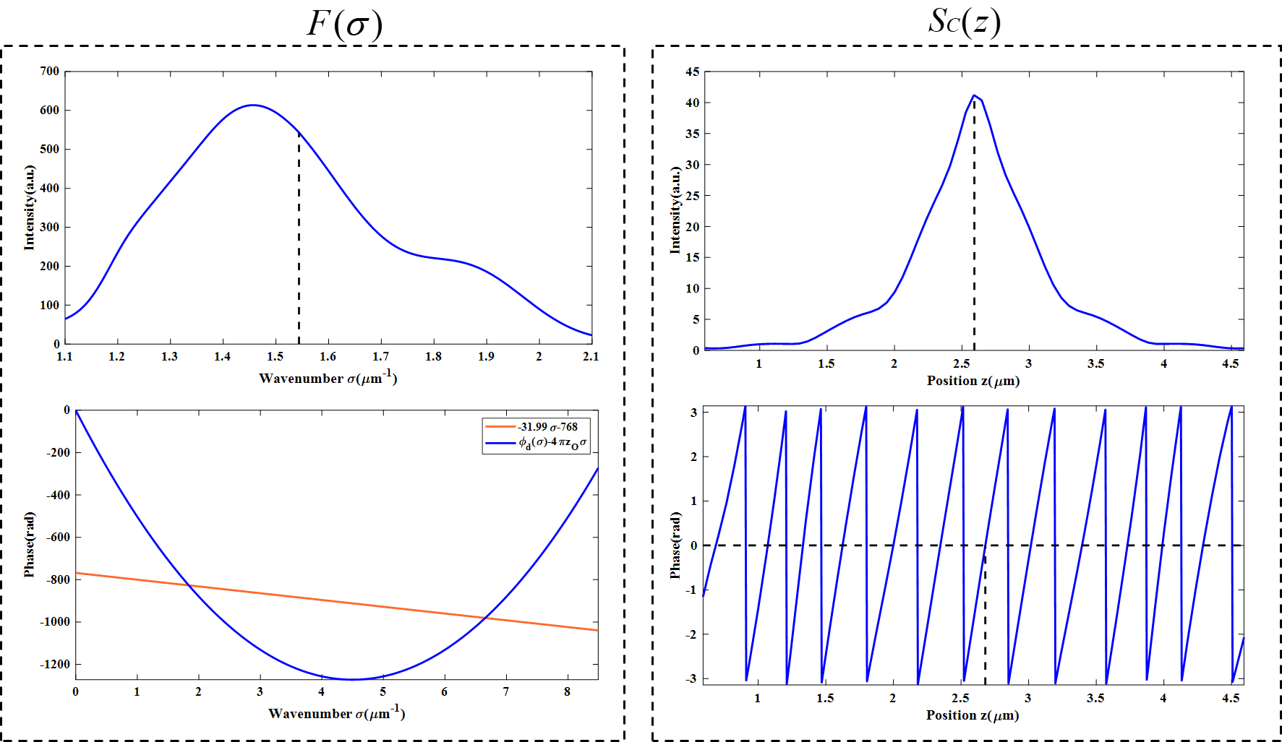

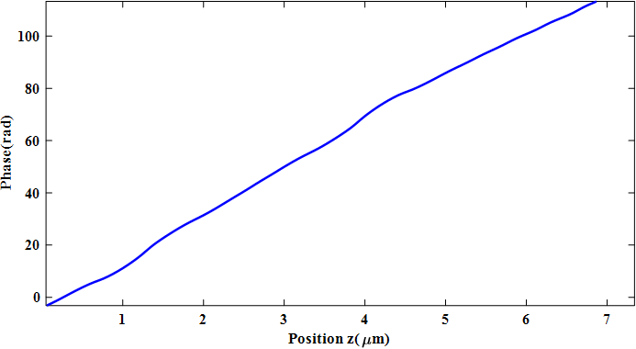

(e)

unwrap

Fig. 6 IFT (Inverse Fourier transform) of *F(σ)*. (a) The intensity of *F(σ)*. (b) The phase of *F(σ)* afterthe least squares method.(c) The intensity of *SC(z)*. (d)The phase of *SC(z).* (e) The unwrap phase of *SC(z).*

[Please rewrite the above content according to the comments. And send me the corrected content first before rewriting the below cases of (2) and (3).]

[Please do not send a lot of contents. Please send small parts such as the content of I and II as soon as possible. Next please send III (1), next III(2) and (3).]

-----------------------------------------------------------------

1. **When b0 is 10, b1 is -1 and φd(σ) = -4π(10-1σ)σ;**

In the same way, the amplitude and phase of the inverse Fourier transform of *F(σ)* can be obtained, as shown in Fig.7. The relevant parameters can be obtained from Fig.6 are shown in Table 5.

Table 5. The relevant parameters of *F(σ)* and *SC(z).*

|  |  |  |  |  |  |
| --- | --- | --- | --- | --- | --- |
| σA | zO | λA | za | zp | T |
| 1.5510μm-1 | 10μm | 0.6447μm | 16.9456μm | 16.8688μm | 0.3232μm |
| b0 | b1 | b2 | b3 | zp-zO |  |
| 10 | -1 | 0 | 0 | 6.8688μm |  |

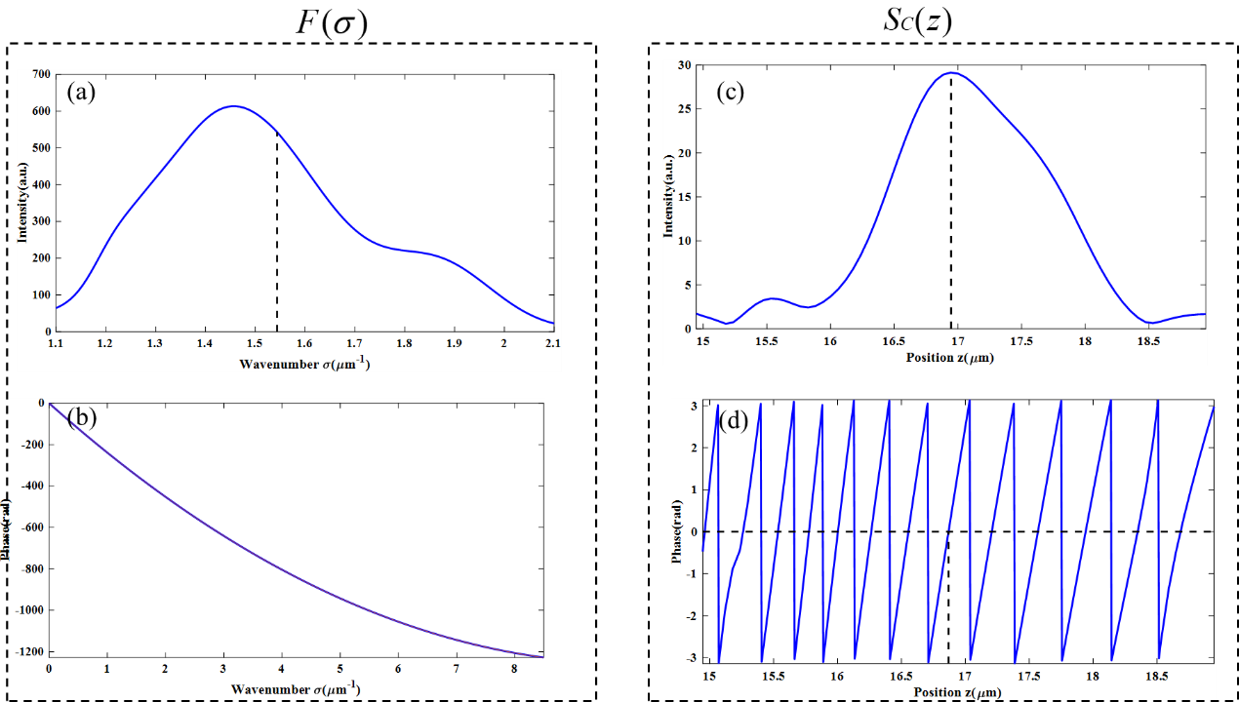  


(e)

unwrap

Fig. 7 IFT (Inverse Fourier transform) of *F(σ)*. (a) The intensity of *F(σ)*. (b) The phase of *F(σ)*.

(c) The intensity of *SC(z)*. (d)The phase of *SC(z).* (e) The unwrap phase of *SC(z).*

The inverse Fourier transform process after linear fitting by the least squares method is shown in Fig. 8, and the relevant parameters are shown in Table 6.

Table 6. The relevant parameters of *F(σ)* and *SC(z).*

|  |  |  |  |  |  |
| --- | --- | --- | --- | --- | --- |
| σA | zO | λA | za | zp | T |
| 1.5510μm-1 | 10μm | 0.6447μm | 11.5851μm | 11.7132μm | 0.3292μm |
| a0 | a1 | zp-zO |  |  |  |
| -153.6 | 19 | 1.7132μm |  |  |  |

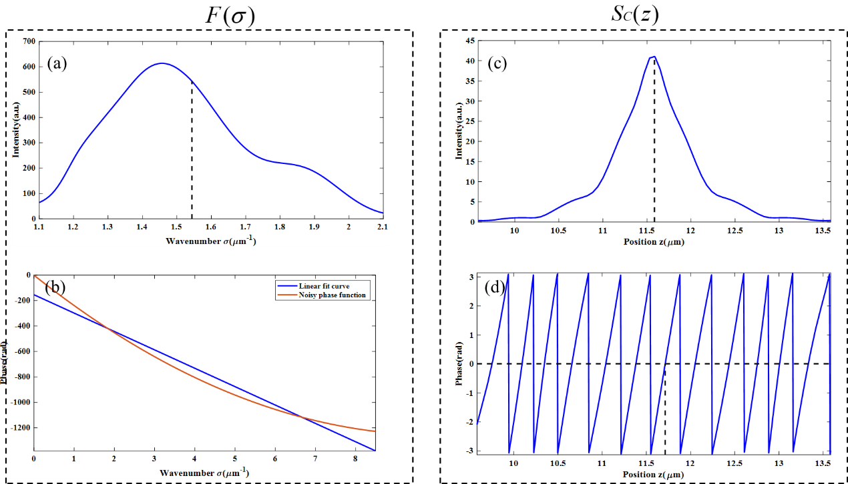

Fig. 8 IFT (Inverse Fourier transform) of *F(σ)*. (a) The intensity of *F(σ)*. (b) The phase of *F(σ)* afterthe least squares method.(c) The intensity of *SC(z)*. (d)The phase of *SC(z).* (e) The unwrap phase of *SC(z).*

1. **When b0 is 16, b1 is -6 and φd(σ) = -4π (26 - 6σ)σ;**

In the same way, the amplitude and phase of the inverse Fourier transform of *F(σ)* can be obtained, as shown in Fig.9. The relevant parameters can be obtained from Fig.6 are shown in Table 7.

Table 7. The relevant parameters of *F(σ)* and *SC(z).*

|  |  |  |  |  |  |
| --- | --- | --- | --- | --- | --- |
| σA | zO | λA | za | zp | T |
| 1.5510μm-1 | 10μm | 0.6447μm | 8.41697μm | 8.35911μm | 0.3350μm |
| b0 | b1 | b2 | b3 | zp-zO |  |
| 16 | -6 | 0 | 0 | -1.64089μm |  |

The inverse Fourier transform process after linear fitting by the least squares method is shown in Fig. 10, and the relevant parameters are shown in Table 8.

Table 8. The relevant parameters of *F(σ)* and *SC(z).*

|  |  |  |  |  |  |
| --- | --- | --- | --- | --- | --- |
| σA | zO | λA | za | zp | T |
| 1.5510μm-1 | 10μm | 0.6447μm | 35.3546μm | 35.3688μm | 0.3233μm |
| a0 | a1 | zp-zO |  |  |  |
| -905.1 | 439.1 | 15.3688μm |  |  |  |

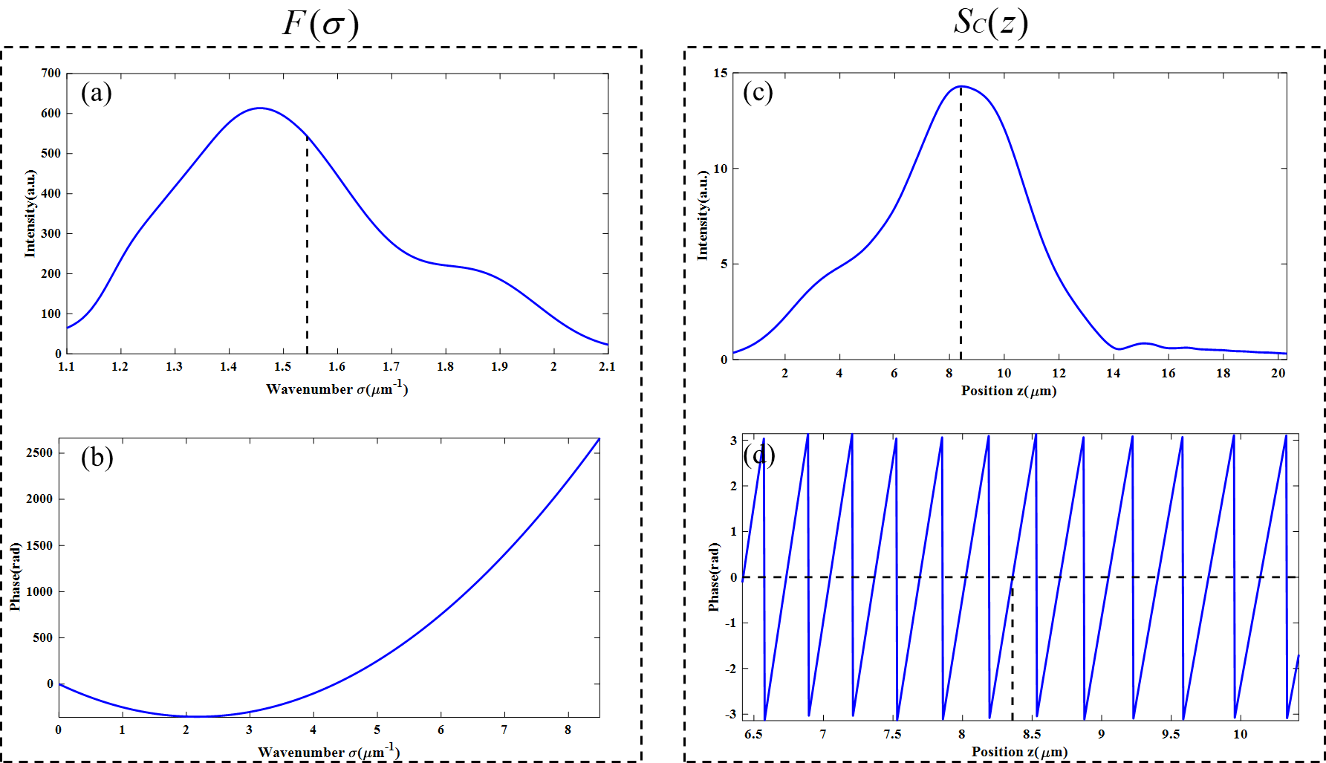

(e)



unwrap

Fig. 9 IFT (Inverse Fourier transform) of *F(σ)*. (a) The intensity of *F(σ)*. (b) The phase of *F(σ)*.

(c) The intensity of *SC(z)*. (d)The phase of *SC(z).* (e) The unwrap phase of *SC(z).*

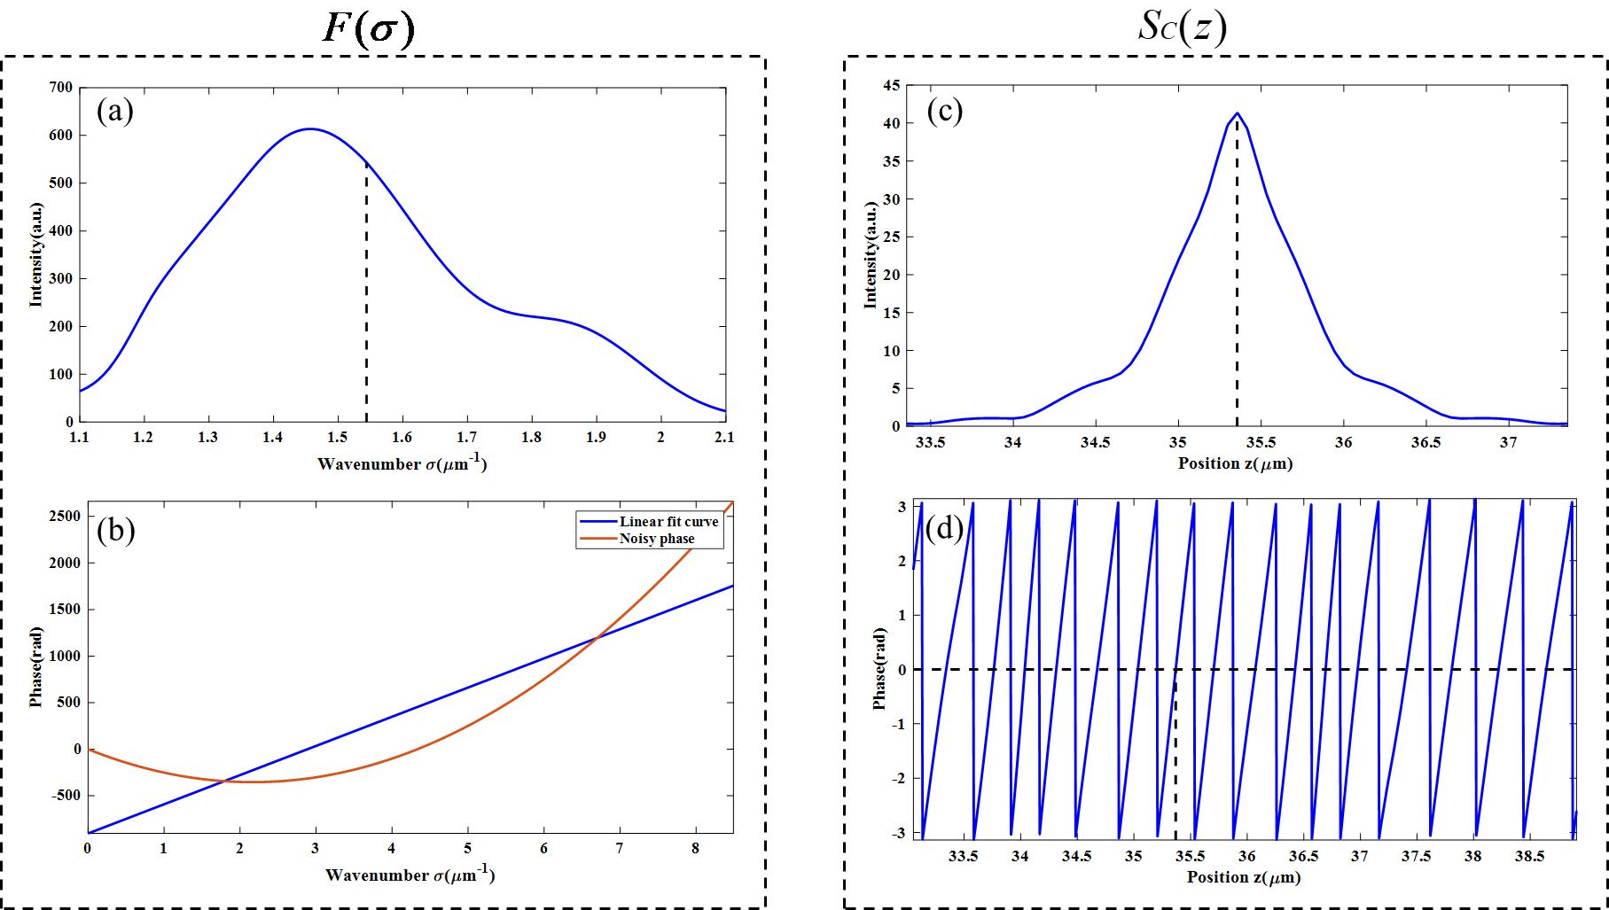

Fig. 10 IFT (Inverse Fourier transform) of *F(σ)*. (a) The intensity of *F(σ)*. (b) The phase of *F(σ)* afterthe least squares method.(c) The intensity of *SC(z)*. (d)The phase of *SC(z).*

To sum up, for different noises, whether to use least squares fitting has a great impact on good measurement results. According to Eq.(25) and Eq.(24), the parameters fitted by the least squares method will have a certain impact on zp. If the following condition is satisfied, the value of zp does not changed by noises and the smaller the value of N, the closer zp is to zO.



From the above three situations, we can see that there is an opposite trend between a0 and a1 in the least squares method. Therefore, the measured value of zp is closer to zO than to za.